**TASK 2**

1. List all customers

O/P

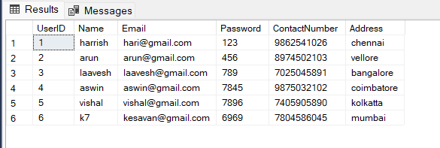

1. List all orders for a specific customer

O/P



1. List all couriers:

o/p

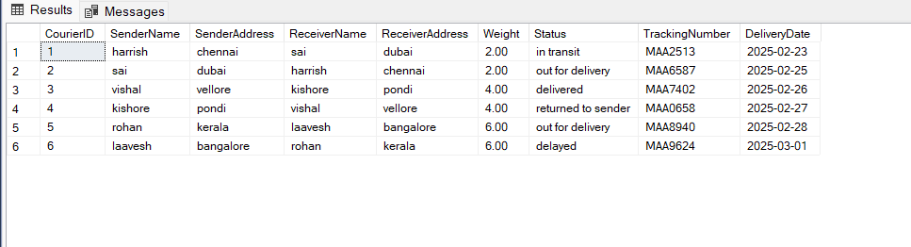

1. List all packages for a specific order:

o/p

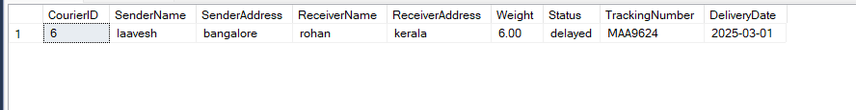

1. List all deliveries for a specific courier

o/p

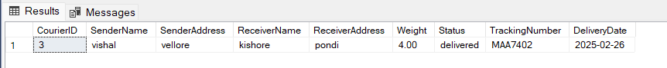

1. List all undelivered packages:

o/p

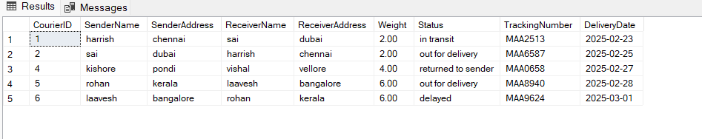

1. List all packages that are scheduled for delivery today:

o/p

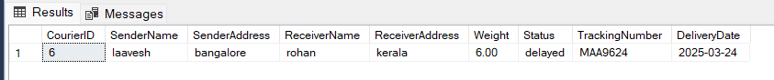

1. List all packages with a specific status:

o/p



1. Calculate the total number of packages for each courier.

o/p

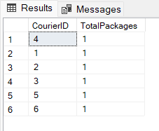

1. Find the average delivery time for each courier

o/p

1. List all packages with a specific weight range:

o/p

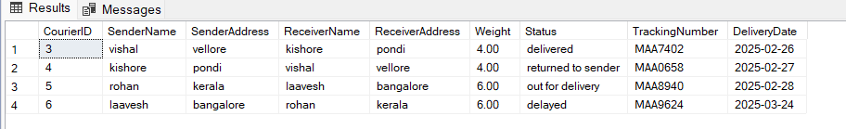

1. Retrieve employees whose names contain 'John'

o/p

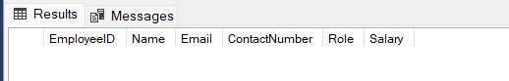

No employee with name John

1. Retrieve all courier records with payments greater than $50.

o/p

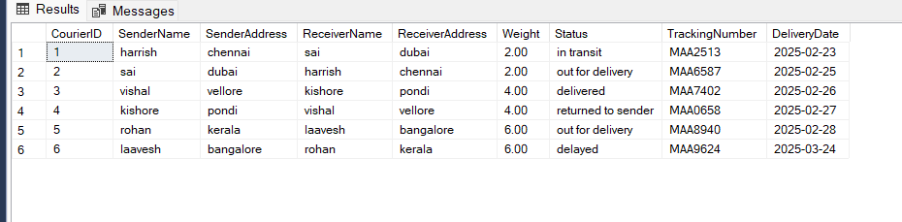

**TASK 3**

1. Find the total number of couriers handled by each employee.

O/P

1. Calculate the total revenue generated by each location

O/P

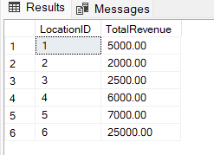

1. Find the total number of couriers delivered to each location

O/P

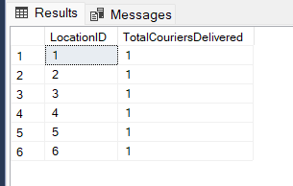

1. . Find the courier with the highest average delivery time:

O/P

1. Find Locations with Total Payments Less Than a Certain Amount

O/P

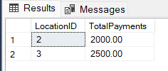

1. Calculate Total Payments per Location

O/P

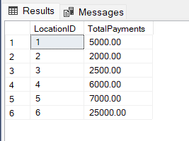

1. Retrieve couriers who have received payments totaling more than $1000 in a specific location (LocationID = X):

O/P

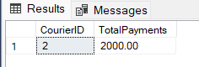

1. Retrieve couriers who have received payments totaling more than $1000 after a certain date (PaymentDate > 'YYYY-MM-DD'):

O/P

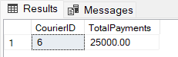

1. Retrieve locations where the total amount received is more than $5000 before a certain date (PaymentDate > 'YYYY-MM-DD')

O/P

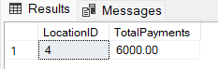

**TASK 4**

1. . Retrieve Payments with Courier Information

O/P

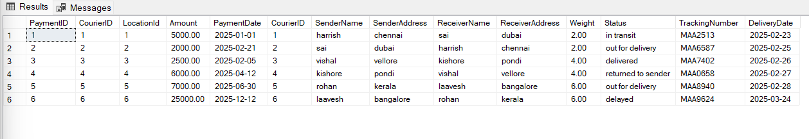

1. Retrieve Payments with Location Information

O/P

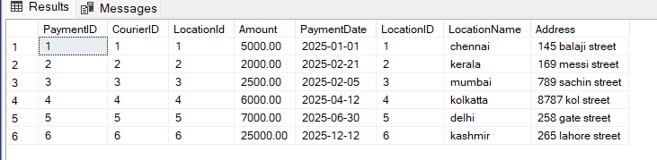

1. Retrieve Payments with Courier and Location Information

O/P

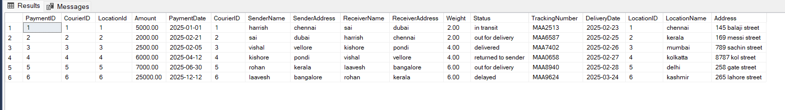

1. List all payments with courier details

O/P

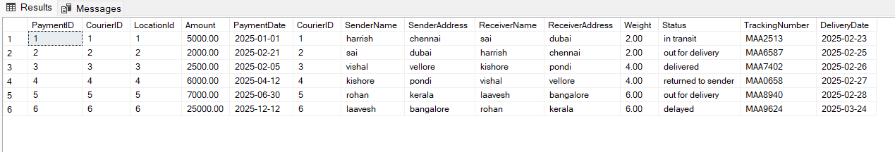

1. Total payments received for each courier

O/P

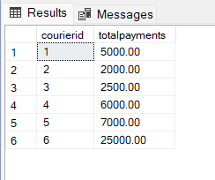

1. List payments made on a specific date

O/P

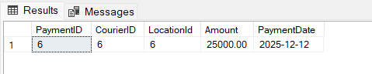

1. Get Courier Information for Each Payment

O/P

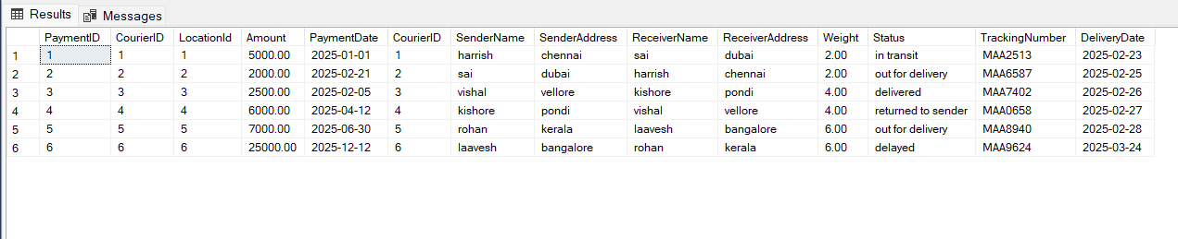

1. Get Payment Details with Location

O/P

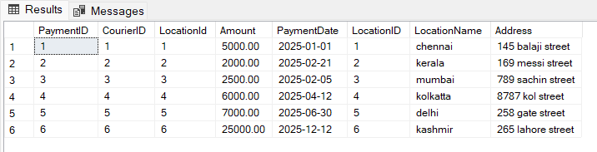

1. Calculating Total Payments for Each Courier

O/P

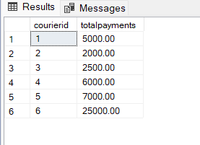

1. List Payments Within a Date Range

O/P

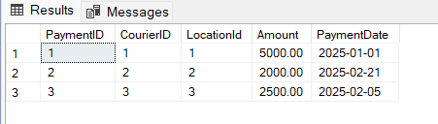

1. Retrieve a list of all users and their corresponding courier records, including cases where there are no matches on either side

O/P

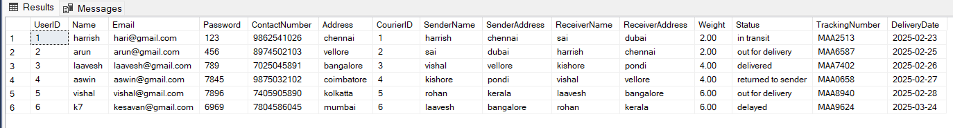

1. Retrieve a list of all couriers and their corresponding services, including cases where there are no matches on either side

O/P

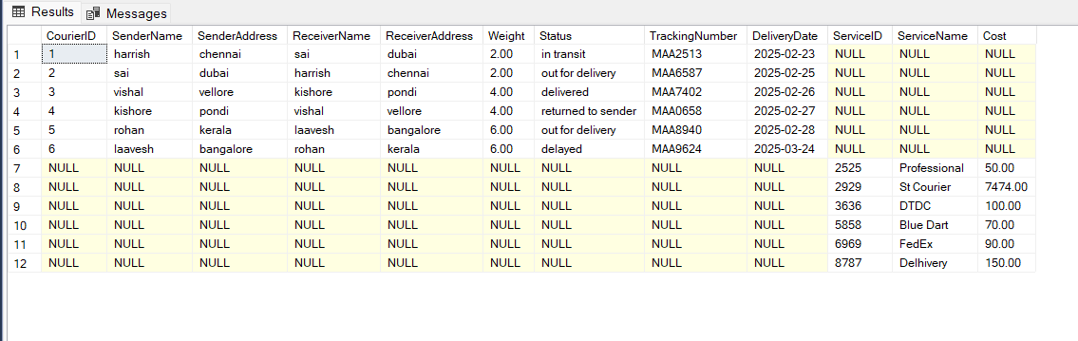

1. Retrieve a list of all employees and their corresponding payments, including cases where there are no matches on either side

O/P

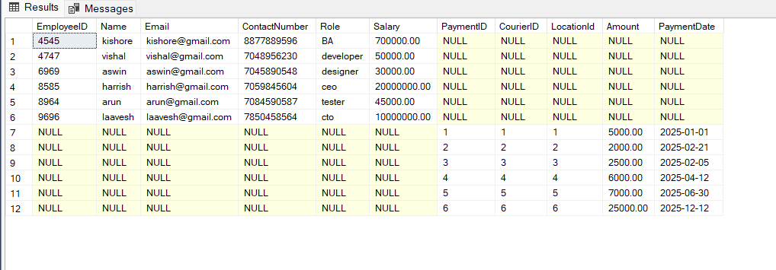

1. List all users and all courier services, showing all possible combinations

O/P

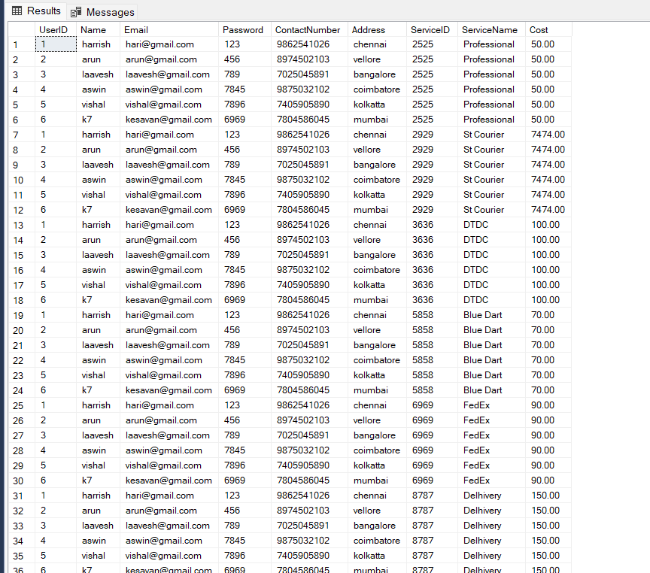

1. List all employees and all locations, showing all possible combinations:

O/P

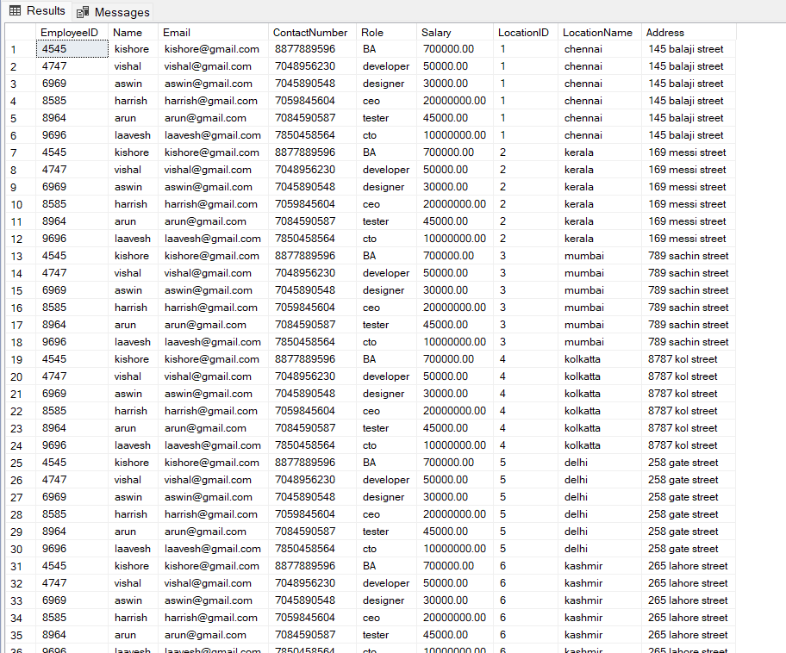

1. Retrieve a list of couriers and their corresponding sender information (if available)

O/P

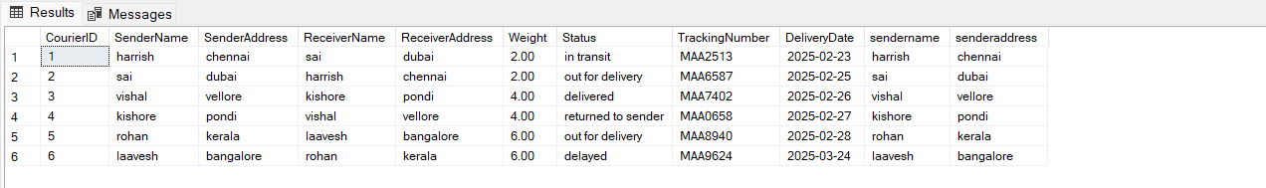

1. Retrieve a list of couriers and their corresponding receiver information (if available):

O/P

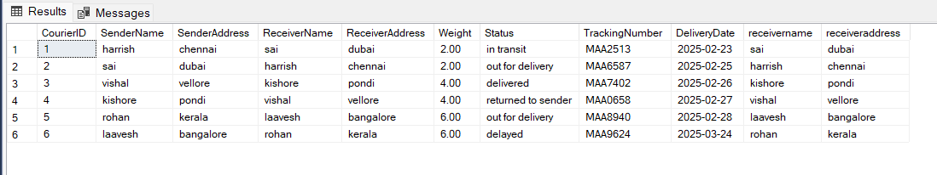

1. . Retrieve a list of couriers along with the courier service details (if available):

O/P

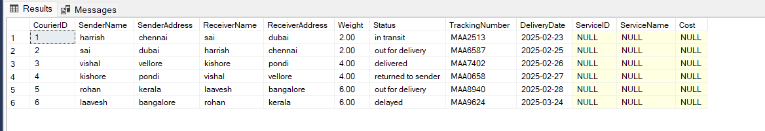

1. Retrieve a list of employees and the number of couriers assigned to each employee:

O/P

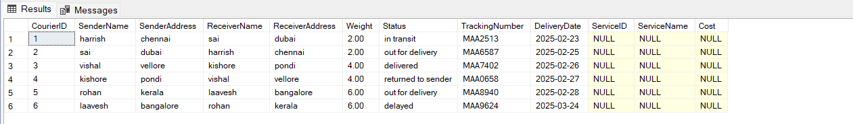

1. Retrieve a list of locations and the total payment amount received at each location:

O/P

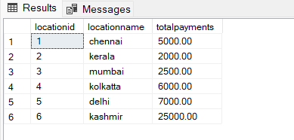

1. . Retrieve all couriers sent by the same sender (based on SenderName).

O/P



1. . List all employees who share the same role.

o/p

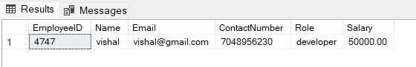

1. Retrieve all payments made for couriers sent from the same location.

o/p

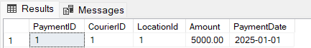

1. Retrieve all couriers sent from the same location (based on SenderAddress).

o/p

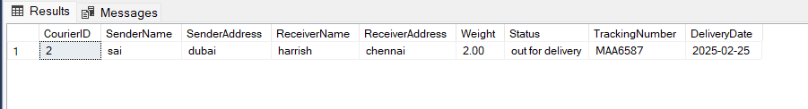

1. . List employees and the number of couriers they have delivered:

o/p

1. Find couriers that were paid an amount greater than the cost of their respective courier services

o/p



No one paid more

1. Find couriers that have a weight greater than the average weight of all couriers

o/p

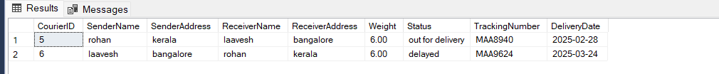

1. Find the names of all employees who have a salary greater than the average salary:

o/p

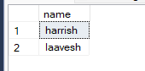

1. . Find the total cost of all courier services where the cost is less than the maximum cost

o/p

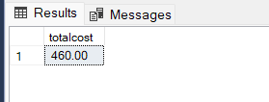

1. Find all couriers that have been paid for

o/p

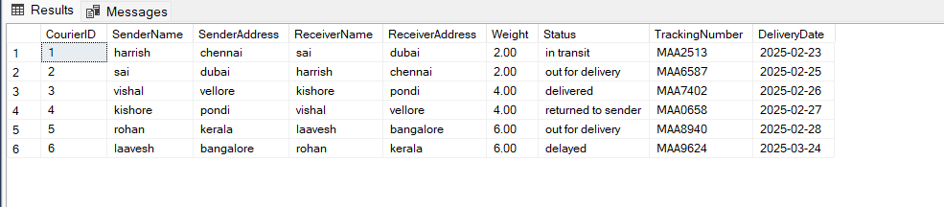

1. Find the locations where the maximum payment amount was made

o/p

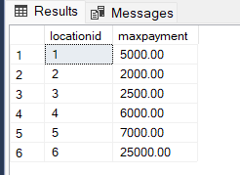

1. Find all couriers whose weight is greater than the weight of all couriers sent by a specific sender (e.g., 'SenderName'):

o/p



No couriers is greater than weight of all customers